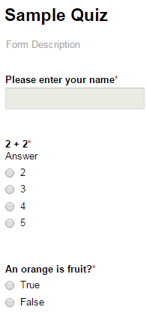**Auto Correcting an Assessment in Google Forms Using Flubaroo**

1. Create an Assessment in Google Forms

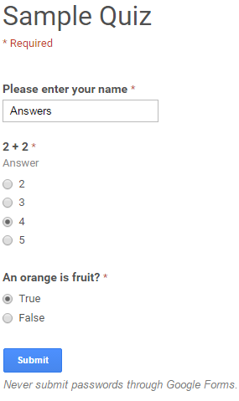

1. Click on “View live form’
2. Complete the Assessment as the Name “Answers”
   1. Answer the Assessment Correctly
   2. Click Submit
3. Have Student’s complete the Assessment
4. Open up Quiz (Responses) located in Drive

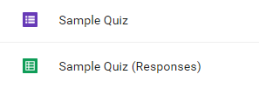

1. Click Add-ons
2. Click Flubaroo
3. 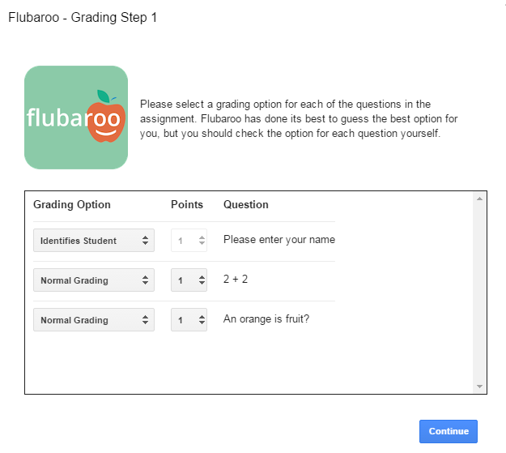Click Enable Flubaroo in this sheet

(You may have to click OK)

1. Click Add-ons
2. Click Flubaroo
3. Click Grade Assignment
4. Select Grading Criteria
5. Click Continue
6. Select Answer Sheet

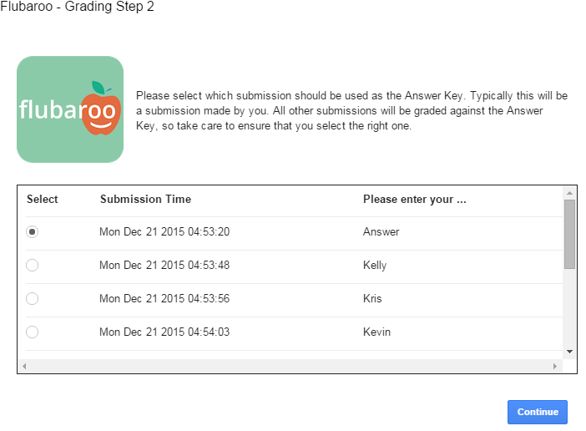

1. Click Continue
2. Flubaroo Grades your assessment